**EASYWAY ON-DEMAND SERVICES**

Ms. Vidisha Vijay Sawant

Department of Computer Science

Pace University, NewYork, USA

[vs10015n@pace.edu](mailto:vs10015n@pace.edu)

Mr. Kshitij Sharma

Department of Computer Science

Pace University, NewYork, USA

[ks81104n@pace.edu](mailto:ks81104n@pace.edu)

Mr. Aditya Kadarla

Department of Computer Science

Pace University, NewYork, USA

[ak42336n@pace.edu](mailto:ak42336n@pace.edu)

Ms. Femina Baldha

Department of Computer Science

Pace University, NewYork, USA

[fb59536n@pace.edu](mailto:fb59536n@pace.edu)

Mr. Shubham Sawant

Department of Computer Science

Pace University, NewYork, USA

[ss97349n@pace.edu](mailto:ss97349n@pace.edu)

Mr. Ravi Kumar Dabbada

Department of Computer Science

Pace University, NewYork, USA

[rd83159n@pace.edu](mailto:rd83159n@pace.edu)

**Abstract**

On-demand services are widely used to get quality services from expert handymen to their doorstep while the customers who are usually busy or do not know how to fix something themselves can save time & effort and can divert their attention to other matters of importance. This advancement is to make life easy and to increase human comfort at home or at work. In today’s date and time, there are several innovations and a rapid growth in service applications that keep sprouting in the real world which hold a wide scope for creativity and logic.

**Keywords**: platforms, on-demand, booking services, handymen

1. **INTRODUCTION**

This last decade has witnessed the emergence and rapid growth of platforms for on-demand services. Examples include food delivery (e.g., Caviar, DoorDash), consumer goods delivery (e.g., UberRush, Go-Mart) and taxi-style transportation (e.g., Fasten, Go-Jek, Lyft, Uber) (Roose 2014, Kokalitcheva 2015, MacMillan 2015, Shoot 2015, Watanabe 2016). These services are on-demand in the sense that upon experiencing a need for service, a customer desires service immediately and is sensitive to delay. In this way, on-demand service platforms are distinct from scheduled service platforms which book appointments in advance (e.g., Amazon Home Services) (Chain Store Age 2016). The “EasyWay" web application aims to aggregate utility services such as beauty, electrical maintenance, home cleaning, pest control, etc on to one platform. The application would enable the end-user to select their preferred service, book an appointment at a convenient time, pay the resultant charge and give feedback. The application aims to be a one-stop shop that caters to all the utility needs of the end user. Our product promises easy booking and cancellation without extra changes and you can maintain your booked services in one place easily.

1. **LITERATURE REVIEW**

Home services are an age-old concept. The “old way” of availing local home services was for professionals (“handymen”) to market themselves through word of mouth, and then to use listing services such as Yelp. Local home services are inherently disorganized, with individuals usually running business operations. Services range from carpentry, plumbing, beauty, laundry, and so on. Think of anything you need in your home that can’t be solved by buying a product. That is likely going to be solved by home services. The trouble is home services are not a commodity. The core reason why people continued to rely on word of mouth after bad experiences, was because it was impossible to tell what you were getting into, even for something as “basic” as plumbing. How do you know the carpenter is good, or the plumber will do a good job? Sure, the industry is ripe for disruption, but how would it get disrupted?

1. **PROJECT REQUIREMENTS**

Mentioned below are the product requirements for making sure the project runs at optimal performance and fulfills its defined functional requirements.

*A. Software Requirements*

* Browser: Mozilla Firefox 65+, Microsoft Edge, Google Chrome, Safari, and Opera
* IDE: IntelliJ IDEA, Visual Studio
* Design: Figma, Miro Board
* Assets: Adobe Photoshop, Lucid Chart
* Database: MySQL, MongoDB
* Version Control: Source Code Hosted on GitHub
* Project Management: Github Projects, JIRA, Slack
* Documentation: Microsoft Word, PDF Expert, Excel, Google Docs

*B. Hardware Requirements*

* Development  
  Apple Macbook: For iOS app development  
  Windows PC: For Android, Web Backend development stack
* End User  
  App: Any iOS, Android device to run the app, Any Web Browser

*C. Functional Requirements*

* The end user will be able to view, and book listed services as required.
* End user could schedule the services in the time slots mentioned.
* User could check the previous history of the services utilized.
* User will get notifications and information of the professional on their web application.
* User can provide feedback and rate the service and the professional.
* End user data would be secure, and the app would preserve privacy as much as possible.
* App will include registration and login features.
* App will suggest multiple professionals according to the ratings provided by other users.

*D. Technical Requirements*

* This is a web application and will support any iOS, Android based devices.
* This web application will be developed using AngularJS, GoLang, NodeJS and utilizes MySQL.

1. SYSTEM DIAGRAM
2. Sequence Diagram

*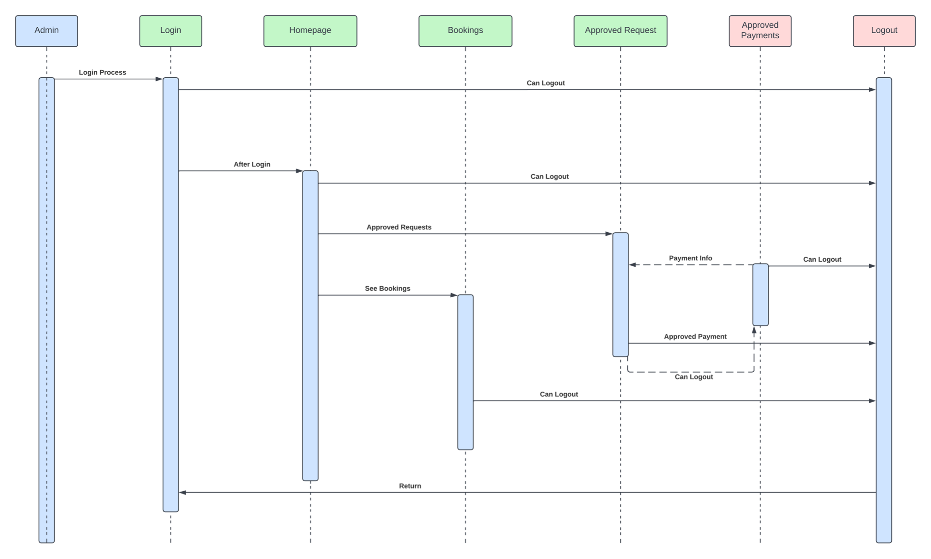 Figure 4.1(a) Admin Sequence Diagram*

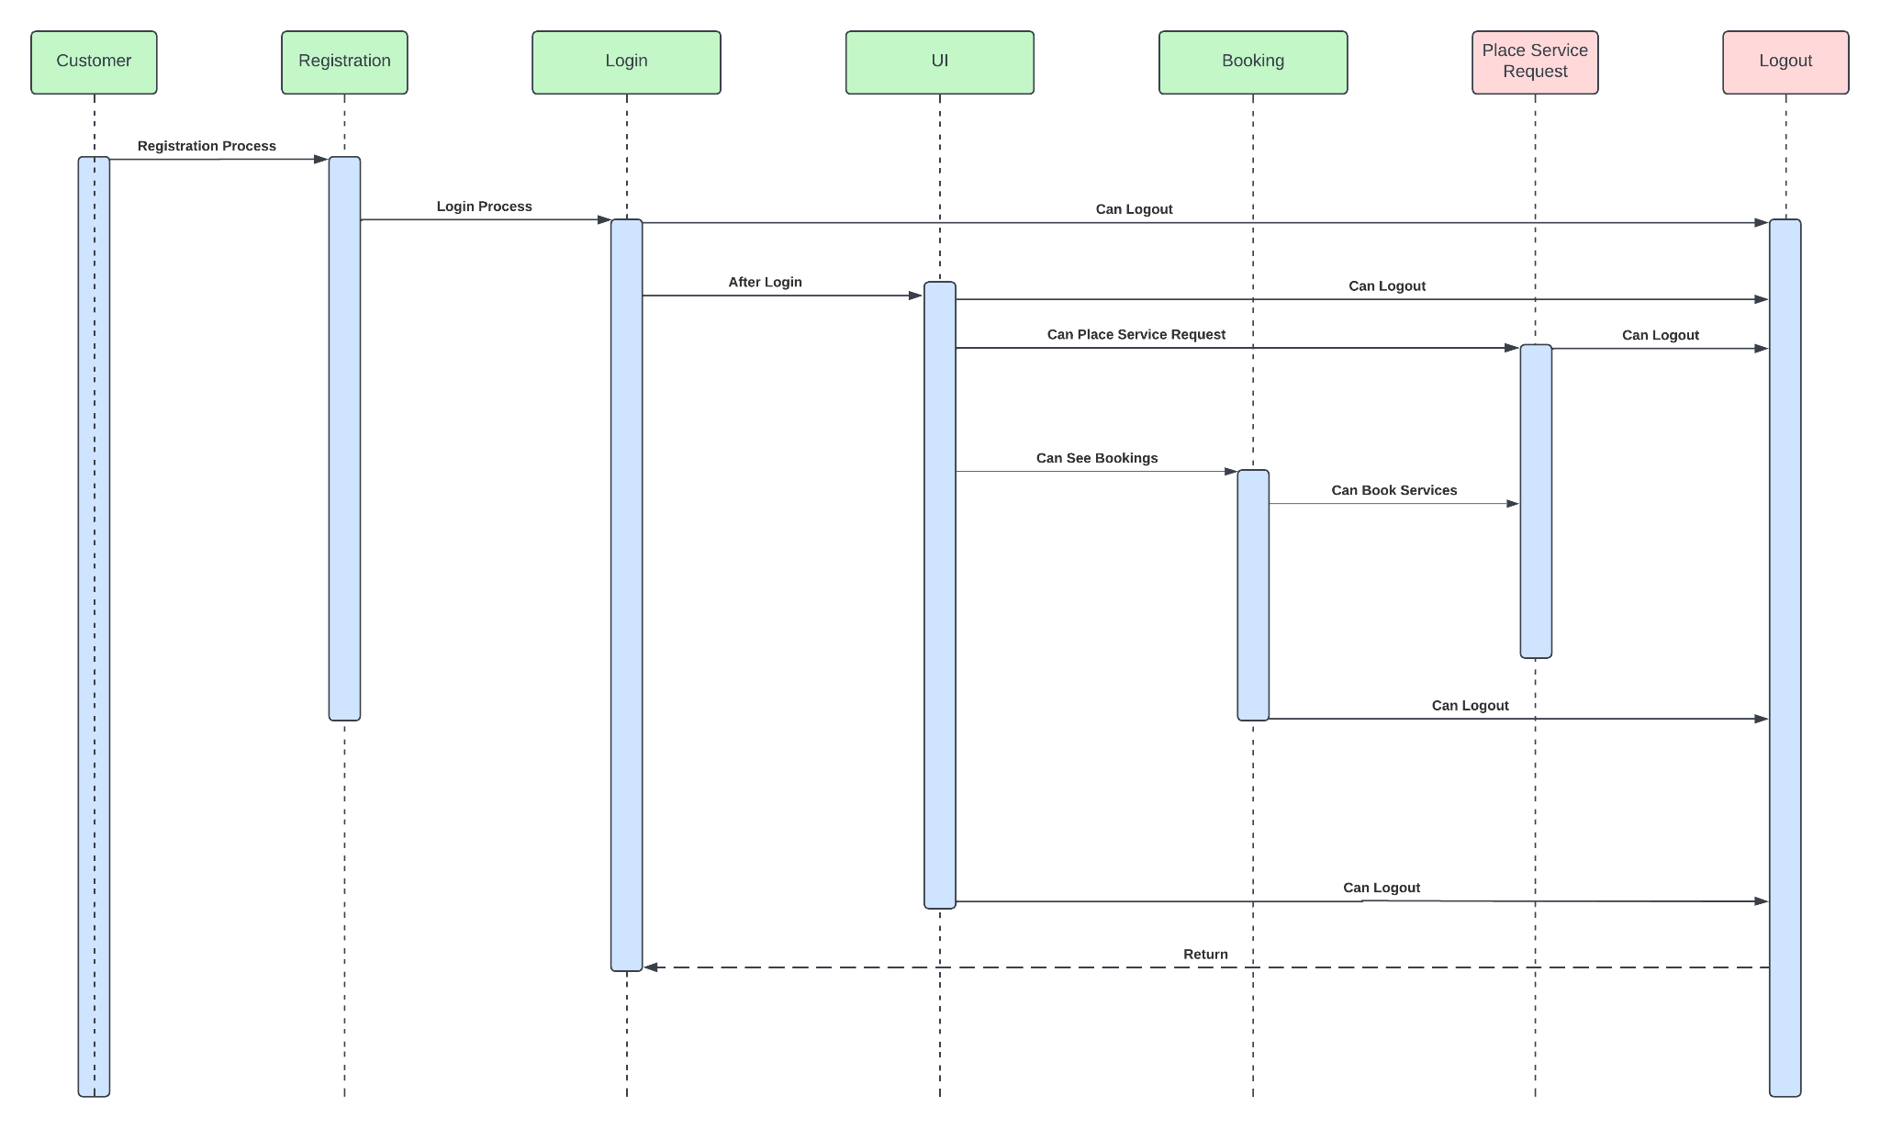

*Figure 4.1(b) User Sequence Diagram*

The image shown in figure 4.1(a) and figure 4.1(b) is the Sequence diagram which is an interaction diagram that shows how objects operate with one another and in what order. It is a construct of a message sequence chart. A sequence diagram shows object interactions arranged in time sequences. The below sequence diagram represents the sequence of action.

1. Control Flow Diagram

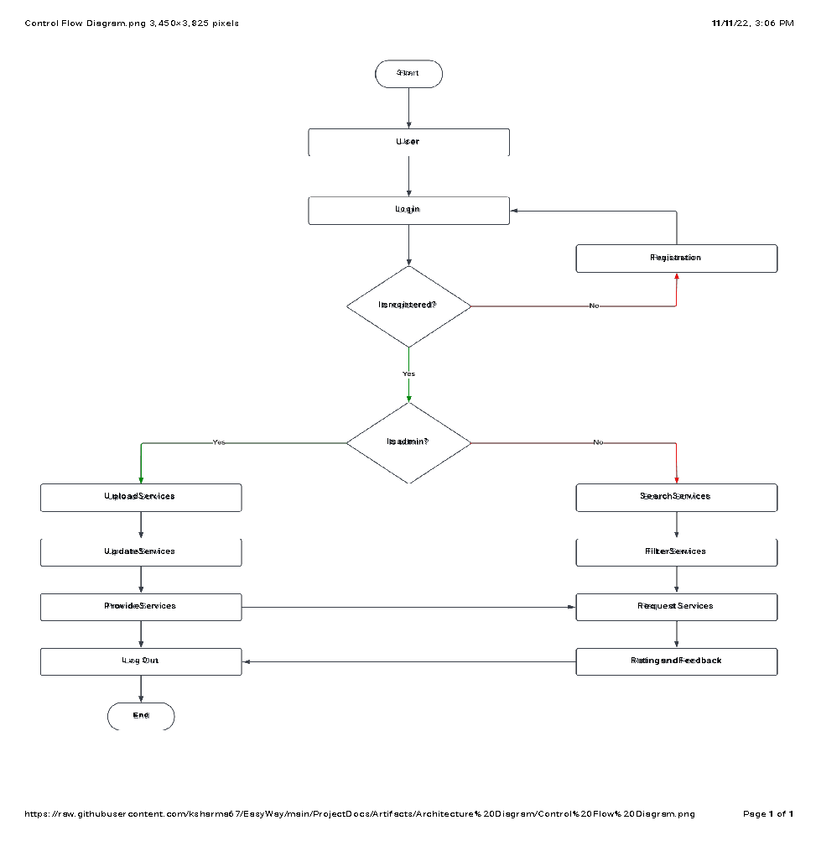

*Figure 4.2 Control Flow Diagram*

1. Data Flow Diagram Level-0

A data flow diagram (DFD) is a graphical representation of the "flow" of data through an information system, modeling its process aspects. In this Data Flow Diagram, we can see how the user display model works. Flow diagrams, in general, are usually designed using simple symbols. It is a way of representing a flow of data of a process or a system. The DFD also provides information about the outputs and inputs of each entity and the process itself. A data-flow diagram has no control flow, there are no decision rules and no loops. Here, we have 2-levels to represent the data flow.

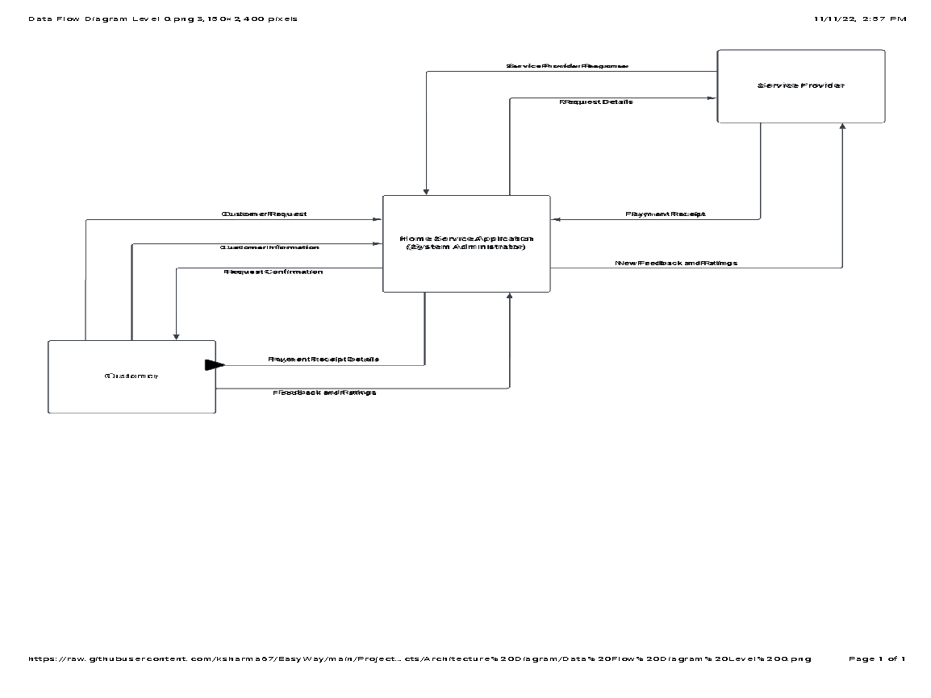

*Figure 4.3 Data Flow Diagram Level 0*

The image shown in figure 4.3 is a Data flow Diagram 0-level is also known as a context diagram. It’s designed to be an abstraction view, showing the system as a single process with its relationship to external entities. It represents the entire system as a single bubble with input and output data. It represents how the customer engages with the home service application, and in turn how the applications forward the request to the service provider and facilitates service.

1. Data Flow Diagram Level-1

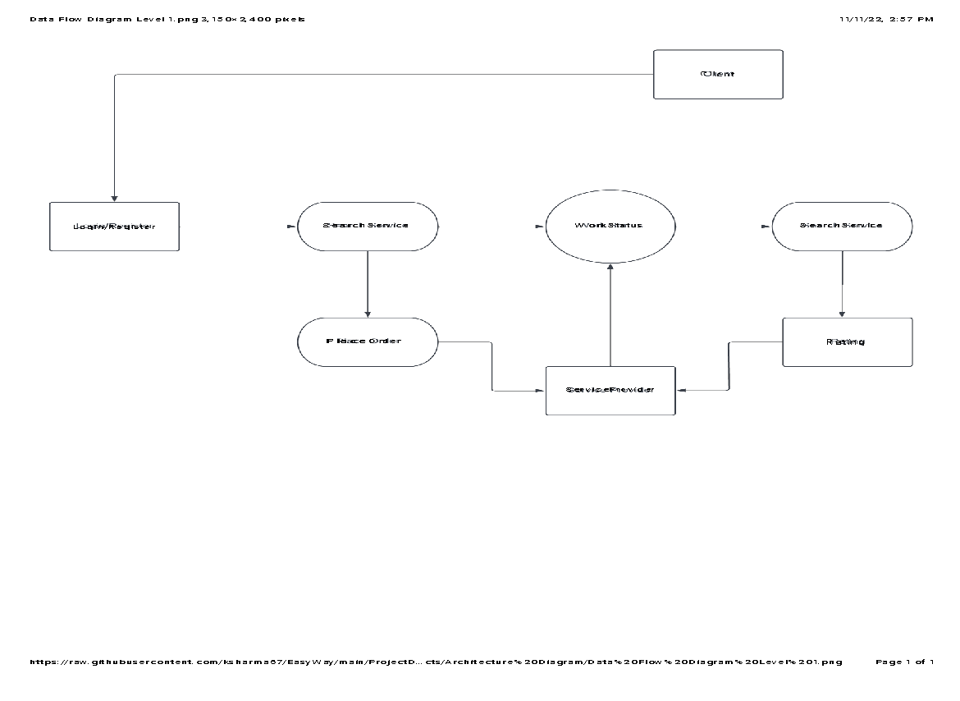

*Figure 4.3 Data Flow Diagram Level 1*

The image shown in figure 4.3 is the Data flow Diagram level 1, a context diagram composed of process. In this, we highlight the main functions of the system and breakdown the high-level process of 0-level Data flow Diagram into the process. It represents the client action starting from login or registering to the application, selection of the service to knowing the work status and making payment for the service availed and providing feedback to the service.

1. Modular Design Representation

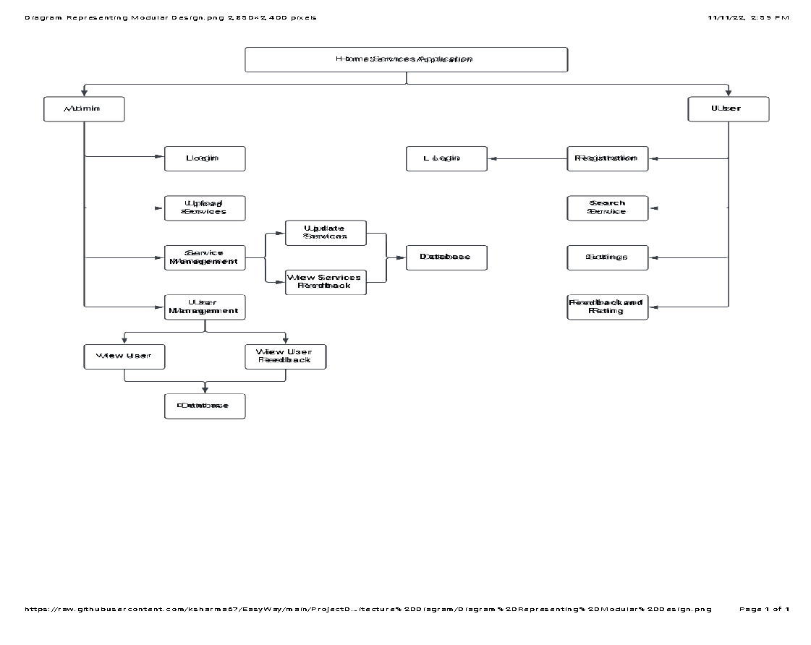

*Figure 4.4 Modular Design Representation*

The modular diagram (shown in figure 4.4) or "modularity in design" is a design approach that subdivides a system into smaller parts called modules that can be independently created and then used in different systems. It represents a home service application having an admin and user panel, each of which shows the respective functions and actions it works on.

1. Architecture Design

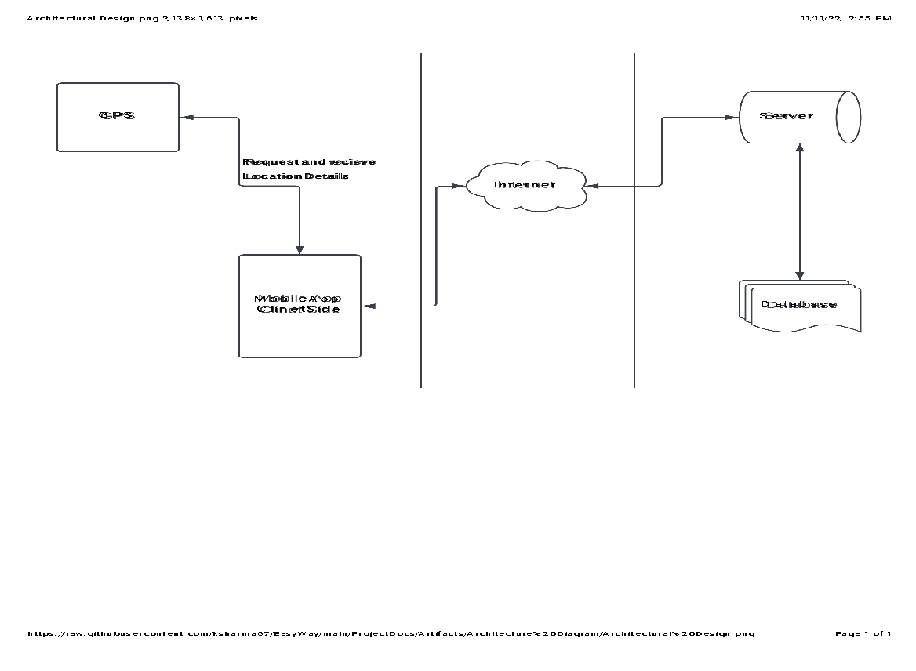

*Figure 4.5 Architecture Diagram*

1. OBJECT DETECTION- WORKING OF ARCHITECTURE

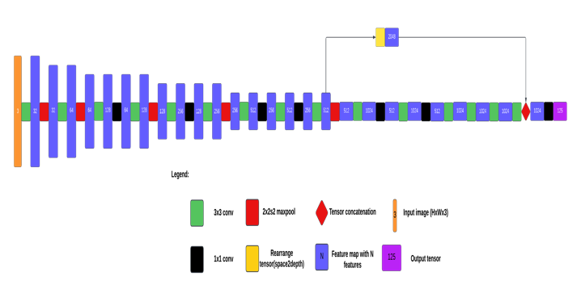

*Figure 4.6 Working of Architecture*

This is **a real-time object detection algorithm** that identifies specific objects in videos, live feeds, or images. This machine learning algorithm uses features learned by a deep convolutional neural network to detect an object. Object classification systems are used by Artificial Intelligence (AI) programs to perceive specific objects in a class as subjects of interest. The systems sort objects in images into groups where objects with similar characteristics are placed together, while others are neglected unless programmed to do otherwise. This is **a Convolutional Neural Network (CNN)** for performing object detection in real-time. CNNs are classifier-based systems that can process input images as structured arrays of data and recognize patterns between them (view Figure 4.6). This has the advantage of being much faster than other networks and still maintains accuracy. It allows the model to look at the whole image at test time, so its predictions are informed by the global context in the image. All other convolutional neural network algorithms “score” regions based on their similarities to predefined classes. High-scoring regions are noted as positive detections of whatever class they most closely identify with.

1. OBJECT DETECTION- NETWORK ARCHITECTURE

*Figure 4.7 Network Architecture*

1. DATABASE SCHEMA
2. USE CASE

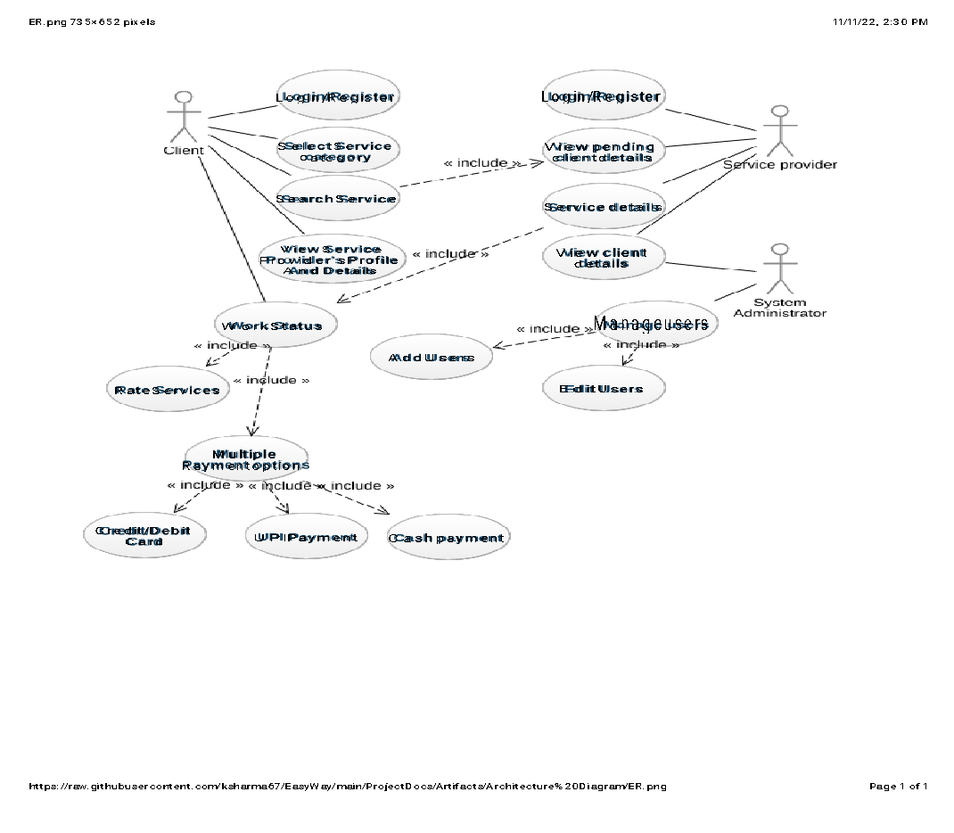

*Figure 4.8 Use Case Diagram*

1. ER Diagram

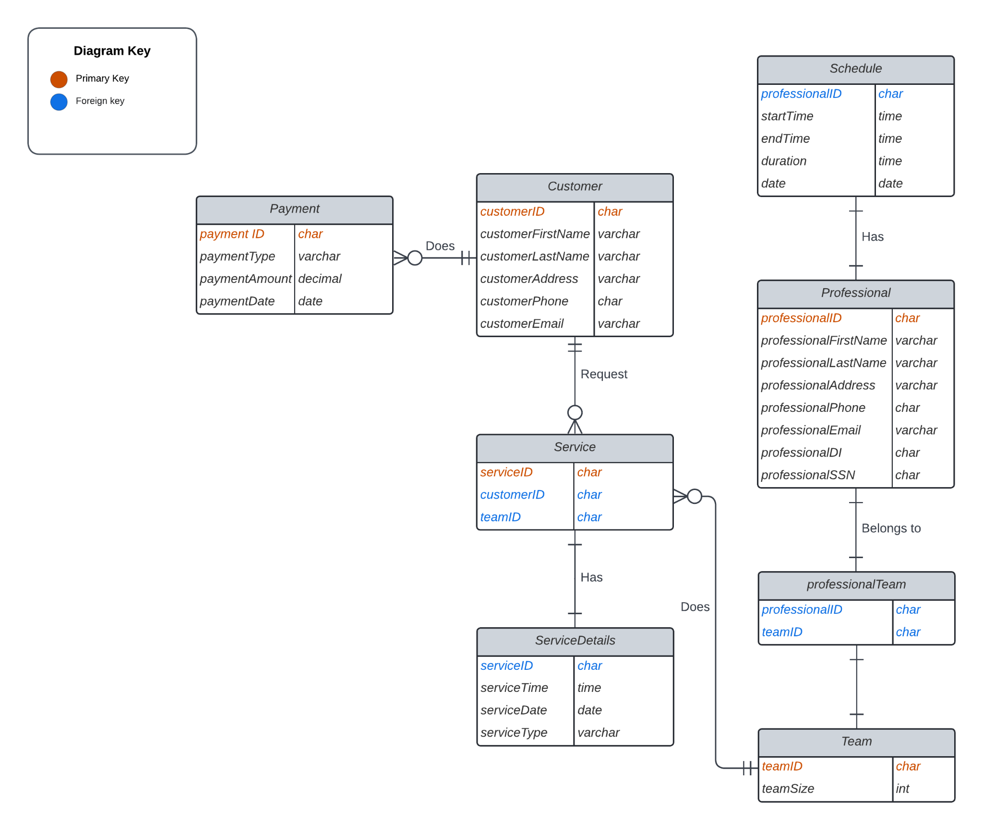*Figure 4.9 Entity Relationship Diagram*

1. BOUNDING BOX PREDICTION:

Our system predicts bounding boxes using dimension clusters as anchor boxes [15]. The network predicts 4 coordinates for each bounding box, tx, ty, tw, th. If the cell is offset from the top left corner of the image by (cx, cy ) and the bounding box prior has width and height pw, ph, then the predictions correspond to:

*Figure 4.10 Sum of Squared Error Loss Formula*

During training we use sum of squared error loss. If the ground truth for some coordinate prediction is tˆ* our gradient is the ground truth value (computed from the ground truth box) minus our prediction: tˆ* − t*. This ground truth value can be easily computed by inverting the equations above.

*Figure 4.11 Bounding boxes with dimension priors and location prediction.*

Tx, ty, tz, th are predicted. During training, sum of squared error loss is used and objectness score is predicted using logistic regression. It is 1 if the bounding box prior overlaps a ground truth object by more than any other bounding box prior. Only one bounding box prior is assigned for each ground truth object.

1. CONCLUSION

In conclusion, this paper shows a web application which provides services which are reliable, and the users can book and schedule them accordingly and can expect an expert handyman to take care of the job for them while they concentrate on other bigger matters. The application will have registration and sign in option to provide user security and will also provide a booking history option to go through all the previous bookings and an option to provide feedback and rate the services and the professionals.

1. SUMMARY

In the whole phase of planning, we will follow an agile approach towards building this application. Bring together an enthusiastic team and plan on the sprint sessions and the respective timelines. After preparing, we develop the project paperwork. We produce the machine code after the build. We allow an error estimate and commitment calculation in the computer design. If a mistake happens, fix it. Finally, when the application is built, check the software, and agree on the expense of the implementation.